Building a Product Recommendation Agent with AWS Lambda and Amazon Bedrock Knowledge Base
- We created an Amazon Bedrock Knowledge Base containing our product catalog.
- The next step is to build an AI agent tool that can retrieve product information from this knowledge base whenever a customer requests product recommendations.
- To accomplish this, we will create an AWS Lambda function that uses the Amazon Bedrock Retrieve and Generate API through the Boto3 SDK.
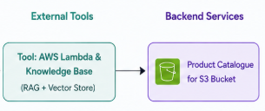

Solution Architecture
The recommendation workflow follows these steps:
- A customer asks a product-related question (for example, “What running shoes do you have?”).
- The Orchestrator Agent identifies that this request requires product recommendations.
- The Recommendation Agent invokes an AWS Lambda function.
- The Lambda function queries the Amazon Bedrock Knowledge Base.
- The knowledge base retrieves relevant information from the product catalog.
- The foundation model generates a natural language response.
- The Lambda function returns the answer to the AI agent, which presents it to the customer.
This Lambda function serves as the Recommendation Agent Tool.

Step 1: Create the AWS Lambda Function
- Begin by creating a new Lambda function.

Configuration
- Function Name: recommend_product
- Runtime: Python 3.x (latest available version)
Once the function is created, increase the execution timeout.

Update Timeout
- Navigate to:
- Configuration → General Configuration
- Change the timeout from the default 3 seconds to 2–3 minutes.
- This ensures the function has enough time to retrieve information from Amazon Bedrock and generate a response.

Step 2: Configure IAM Permissions
- The Lambda function requires permission to access both:
  - Amazon Bedrock
  - Amazon S3
- Open the Lambda execution role and attach the following managed policies:
  - AmazonBedrockFullAccess
  - AmazonS3FullAccess
Note: Full access is acceptable for learning purposes. In production environments, always follow the principle of least privilege by granting access only to the required S3 buckets and Bedrock resources.

Step 3: Connect to Amazon Bedrock Using Boto3
- AWS Lambda uses Boto3, the AWS SDK for Python, to communicate with AWS services.
First, import the required libraries:
- boto3
- json
Next, create a client connection for the Bedrock Agent Runtime service.
- This client is responsible for communicating with the Bedrock Knowledge Base using the Retrieve and Generate API.
https://docs.aws.amazon.com/boto3/latest/reference/services/bedrock-agent-runtime.html
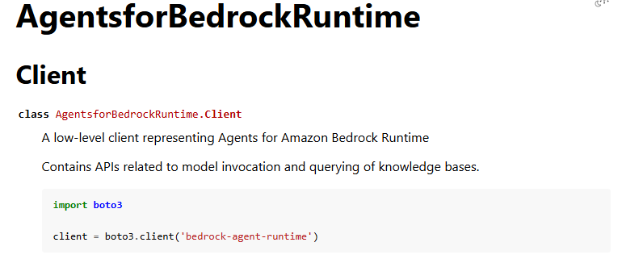

Step 4: Understand the Lambda Handler
- Every Lambda function contains a default handler.
- The handler accepts two parameters:

Event
- The event contains the input received from the calling service.
- In our application, the event contains the customer’s query, for example:
“Show me running shoes.”
- The Lambda function retrieves this value from the event using the key:
  - Prompt
  - Context
The context contains runtime information about the Lambda function, including:
- Memory allocation
- Timeout settings
- Function metadata
For this implementation, only the event input is required.

Step 5: Retrieve the User Prompt
- The first task inside the Lambda function is extracting the user’s request.
For example:
“Which running shoes do you have?”
- This prompt is stored in a variable and will be passed directly to the Bedrock Knowledge Base.

import json
import boto3

#1 Connect to Bedrock Agent Runtime client
client = boto3.client("bedrock-agent-runtime")

def lambda_handler(event, context):
#2 Get the user prompt from the incoming event
prompt = event.get("prompt")

Step 6: Query the Bedrock Knowledge Base
The Lambda function now calls the Retrieve and Generate API.
https://docs.aws.amazon.com/boto3/latest/reference/services/bedrock-agent-runtime/client/retrieve_and_generate.html
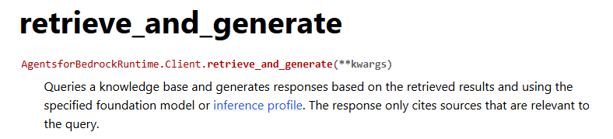
This API performs two operations:
- Retrieves relevant information from the Knowledge Base.
- Uses a Foundation Model to generate a natural language response.

client.retrieve_and_generate()
is an Amazon Bedrock Agent Runtime API method used for Retrieval-Augmented Generation (RAG). It combines two steps into a single API call:
- Retrieve relevant documents from a Bedrock Knowledge Base.
- Generate an answer using a foundation model (FM) based on the retrieved documents.

The request contains two main sections:

Input
The input includes the customer’s prompt.
Example:
“Which running shoes do you have?”

Retrieve and Generate Configuration
This configuration specifies:
- Knowledge Base
- Foundation Model
- Retrieval Type

Step 7: Configure the Knowledge Base
- Three configuration values are required.

1. Knowledge Base ID
- Provide the ID of the Knowledge Base created earlier.
- This identifies which knowledge base should be searched.

2. Foundation Model ARN
The Foundation Model generates the final answer after retrieving the relevant context.
The ARN includes:
- AWS Region
- Foundation Model name
In this project, Amazon Nova Pro is used.
Nova Pro is a good choice for learning because it provides higher request limits compared to some third-party models.

3. Retrieval Type
- Set the retrieval type to:
  - Knowledge Base
- This tells Amazon Bedrock to retrieve information from the configured knowledge base rather than external sources.

Step 8: Generate the Response
- Once the request is sent, Amazon Bedrock returns a structured response.
The response contains several fields, including:
- Metadata
- Citations
- Retrieval details
- Generated output
The actual answer is located inside:
- output
- text
The Lambda function extracts this value and returns it as the final response.

Step 9: Deploy the Lambda Function
After completing the code, deploy the Lambda function.
Deployment packages the code and makes the latest version available for execution.

Step 10: Create a Test Event
Before integrating with the AI agent, test the Lambda function directly.
Create a test event containing a prompt.
Example:
{
"prompt": "Which running shoes do you have?"
}
This simulates the request that will eventually come from the AI agent.

Step 11: Test the Recommendation Tool
Invoke the test event.
The Lambda function performs the following operations automatically:
- Receives the customer prompt.
- Connects to Amazon Bedrock.
- Searches the Knowledge Base.
- Retrieves relevant product information.
- Uses Amazon Nova Pro to generate a response.
- Returns the final answer.
Example response:
The available running shoes include Cloud Runner Running Shoes, along with additional product details retrieved from the product catalog.
This confirms that the recommendation tool is functioning correctly.

End-to-End Flow
The complete recommendation workflow is:
- Customer submits a product-related query.
- The Orchestrator Agent detects a recommendation request.
- The Recommendation Agent invokes the AWS Lambda tool.
- Lambda calls the Bedrock Retrieve and Generate API.
- The Knowledge Base retrieves product information from the PDF catalog.
- Amazon Nova Pro generates a conversational response.
- The recommendation is returned to the customer.

Key Takeaways
In this lecture, you learned how to:
- Create an AWS Lambda function for product recommendations.
- Configure execution timeout and IAM permissions.
- Connect Lambda to Amazon Bedrock using the Boto3 SDK.
- Retrieve customer prompts from Lambda events.
- Use the Retrieve and Generate API to query a Bedrock Knowledge Base.
- Configure the Knowledge Base ID, Foundation Model ARN, and retrieval type.
- Extract the generated response from the API output.
- Test the Lambda function using a sample customer prompt.
This Recommendation Agent Tool forms the foundation of the product recommendation capability within the AnyCart Multi-Agent AI application. In the upcoming sections, it will be integrated with the LangGraph-based agent workflow to provide intelligent, conversational shopping assistance.

